**Uon Id: 21422064**

**Aayush Shrestha**

**CSY2028 Web report**

CheckList:

|  |  |  |  |
| --- | --- | --- | --- |
| Feature | Completed? | Relevant files | Notes |
| Change to Sunday closed | Yes | carsFunctions/templateLoader.php | Changed by use of function: |
| New Page called  ‘Claire’s Careers’  Added. Showing the message ‘*Claire’s Cars currently has no job opportunities available, but keep checking as new positions become available regularly!’* | Yes | templates/careers.html.php,  WebControllers/mainController.php ( function ourCareers()) | There is Job table in database to add job title and description |
| The added manufacturers appears on the list on the Showroom page. | Yes | templates/cars.php,  WebControllers/mainController.php ( function ourCars()) | Manufactures are shown in sidebar/list via fetching through database |
| Archive and Restore car features. | Yes | templates/admin/cars.html.php,  WebControllers/adminController.php ( function: archiveCar(), archivePage(), restoreCar()) | Archived cars are not visible to public part of website |
| Able to store the earlier price.  Eg: The website shows ‘ Was *£2,500, now £2,000’* | Yes | templates/admin/addcar.html.php  templates/cars.php  WebControllers/adminController.php ( function: addCar())  WebControllers/mainController.php ( function: ourCars()) | The price old price is asked to input while editing car details. And old price is shown in public part of website if it is stored in database |
| Able to add Multiple user by using username, and password, seperated by role ( ADMIN or USER ) in database table.  Login user can see who added which cars. | Yes | templates/admin/addAdmin.html.php  templates/admin/addcar.html.php  templates/admin/cars.html.php  WebControllers/adminController.php ( function: addCar(), addAdmin(), showAdmins(), adminCars()) | There are different login credentials for different users.  User having role ‘ADMIN’ can manage manufactures, cars, articles, add job, enquiries, Admins, archived Cars.  User having role ‘USER’ can manage articles, enquiries, Add and archive cars, |
| Separate field for storing mileage, engine type(petrol or diesel). And displayed then in consistent way which is visible in website | Yes | templates/admin/addcar.html.php  WebControllers/adminController.php ( function: addCar())  templates/cars.php,  WebControllers/mainController.php ( function ourCars()) | These two field can be stored in database while adding cars and displayed in showroom page of website. |
| Multiple images of different angles of car can be uploaded. | Yes | templates/admin/addcar.html.php  WebControllers/adminController.php ( function: addCar())  templates/cars.php,  WebControllers/mainController.php ( function ourCars()) | User can add multiple images. And these different images are shown in showroom page. |
| Able to add news stories along with image. | Yes | templates/admin/addArticle.html.php  templates/cars.php,  WebControllers/adminController.php ( function adminArticles(), addArticle())  templates/home.html.php  WebControllers/mainController.php ( function home()) | The added stories are visible in homepage of public part of website |
| Enquiry form in the contact page.  And enquiry submitted shown in admin area. The completed enquiry can be marked as complete and can see previous enquiry | Yes | templates/contact.html.php  templates/admin/enquiries.html.php  WebControllers/adminController.php ( function adminEnquiries(), previousEnquiries())  WebControllers/mainController.php ( function contactUs()) | Can view the previous enquiries. But, there is no way to delete enquiries. |

**Features:**

**Template loader:**

**(templateLoader.php)**

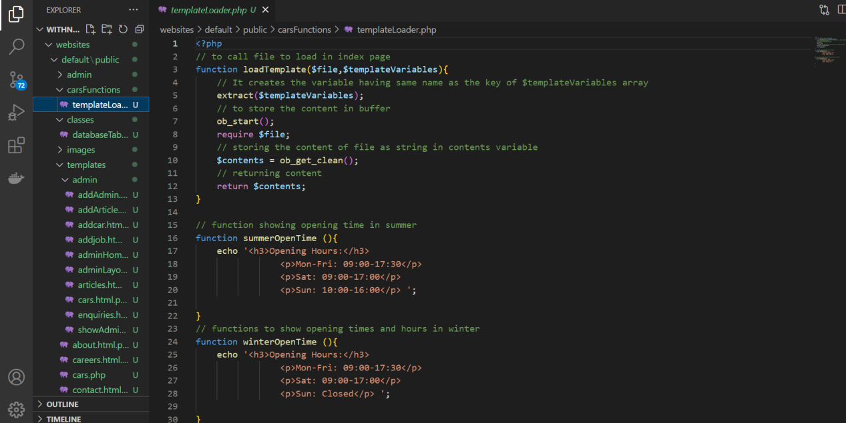

Template loader loads the file to load send by controller and stores in the buffer without displaying it in the browser window and return as string which helps to manage single entry point of the website.

The two functions summerOpenTime(), winterOpenTime() displays the time in the website header.

Controller:

Controller provides the logic for the website, which page to load, database tables object, title of the website.

Main Controller (mainController.php):

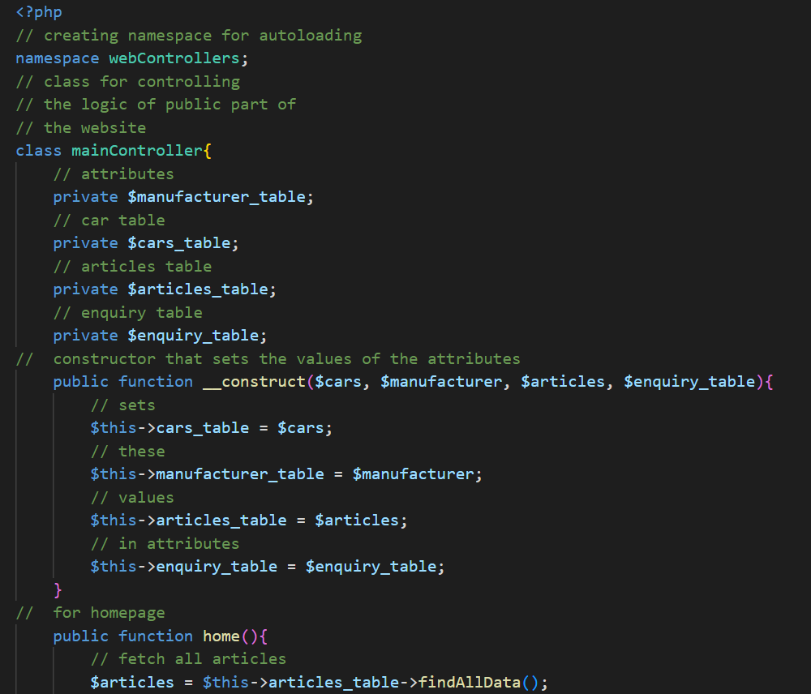

This is the controller created for the public part of the website. Website visible to normal user is controlled by this section. The class of this controller is created so that we the code repeatition for the each page reduces. It sets the instance of each table required for this controller via use of constructor. For each page, different function is created.

Like for homepage or index page home() function is created which fetch all data from the database and returns the template to load, title of the page, and the table instance required by the HTML.

**Admin Controller (adminController.php):**

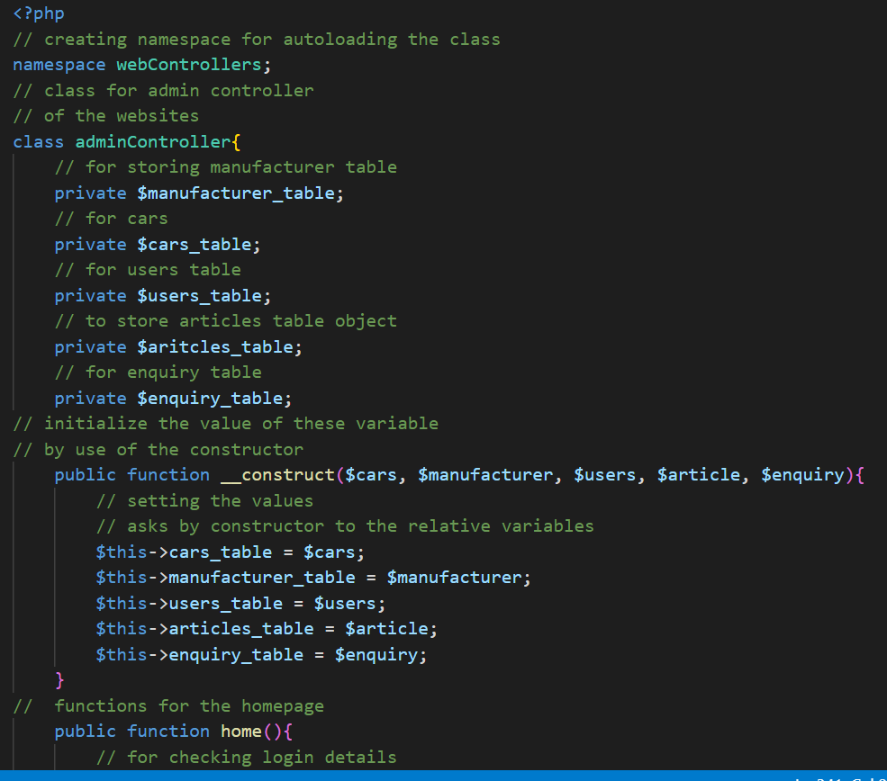

Admin Controller is created to handle logic for the admin view of the website. Every pages of admin panel like ( cars, manufacturers, articles, users, etc) handled by this controller/ class. It sets the object required by this controller to load the admin website.

**Classes/entities(dbTable.php)**

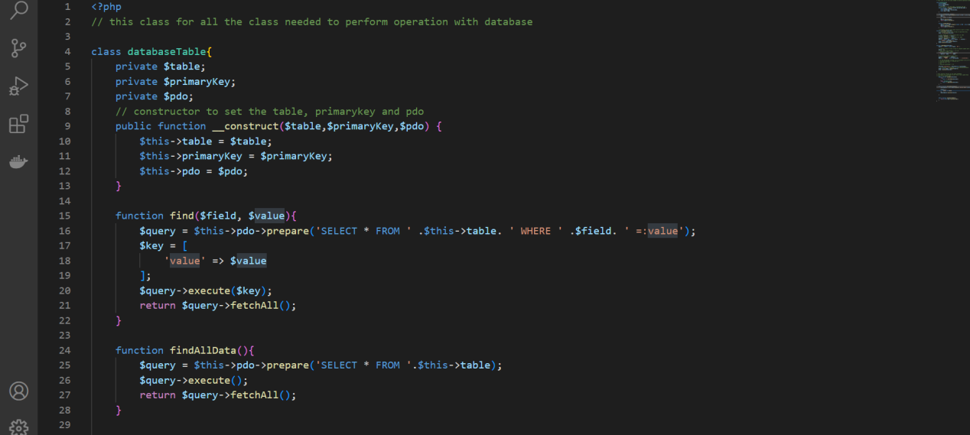

This class is created for handling all the database operation like ( creating, updating, deleting tables, selecting the row or fetching data). It sets $table name to perform database operation, pdo object and primary key of the table. The shown function find perform SELECT query based on field and value provided wherease, findAllData() fetch all data or select all data from the given table.

**Single Entry point(Index.php)**

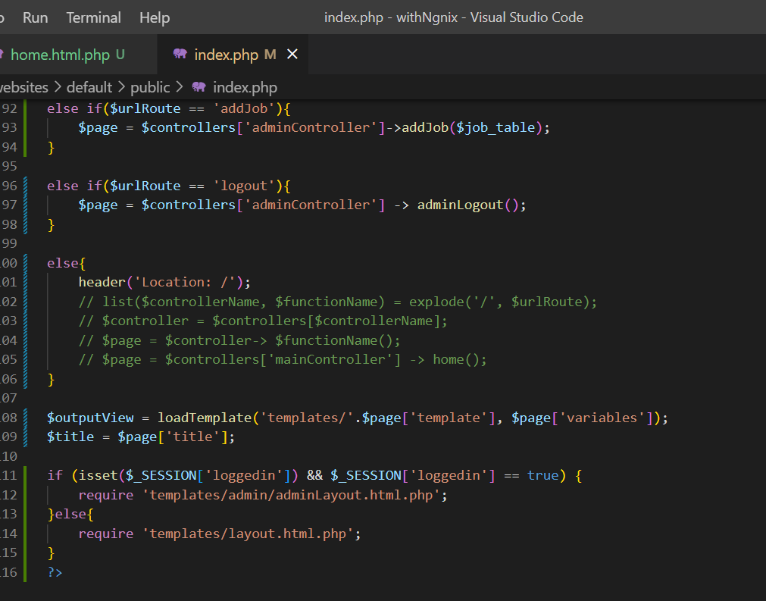

All the URL’s requested by the website is handled by this page. It instantiate all the object/ values require by the controller and loads the relative template. Like, If users requests for homepage, the if condition checks for the matching value obtained from $_GET with the if condition, it calls the function home() and loads the relative table by storing in the $outputView, and calls the required layout for the website.

**Common Layout ( For public view)**

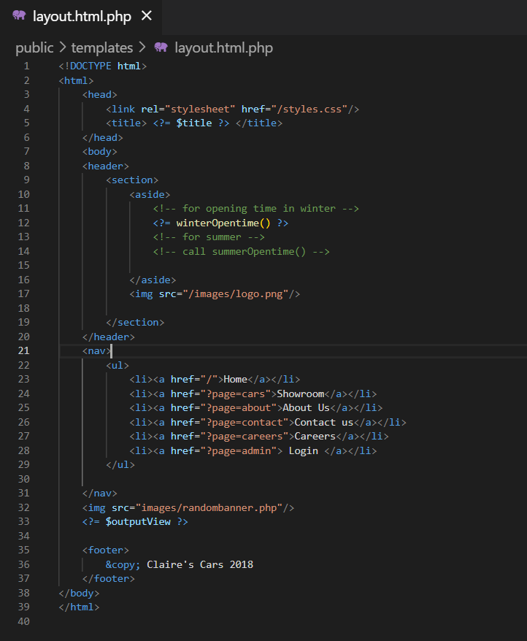

This is the common HTML layout for the public part of the website. The repeated HTML code provided by the client is requced by the use of this layout concept. By using this page it reduces repeating HTML code for every website. Single HTML page works for all page of the website.

The result stored in $outputView is print in this layout (line no 33 in code)

**Admin layout: ( for admin view)**

This is the common HTML layout for the admin view of the website. The repeated code of the admin section of the website is seperated and placed in this .php file. When user is logged in the index.php calls this layout.

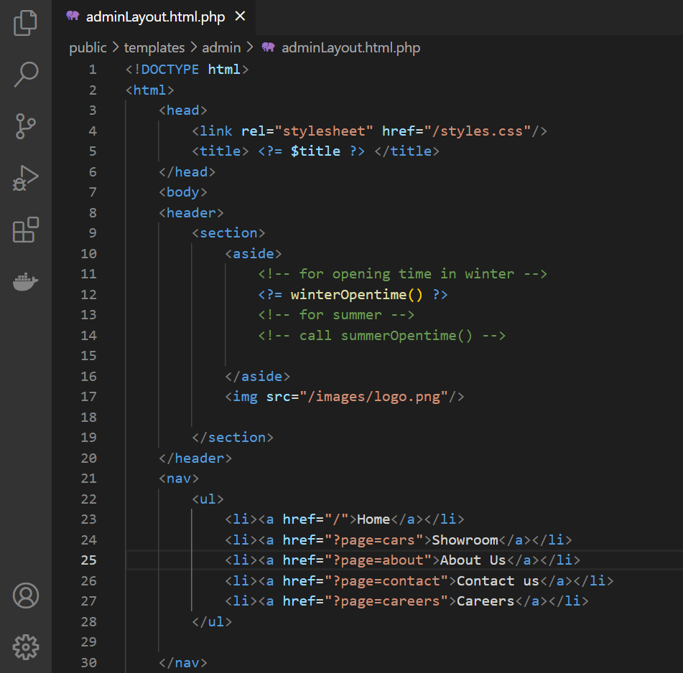

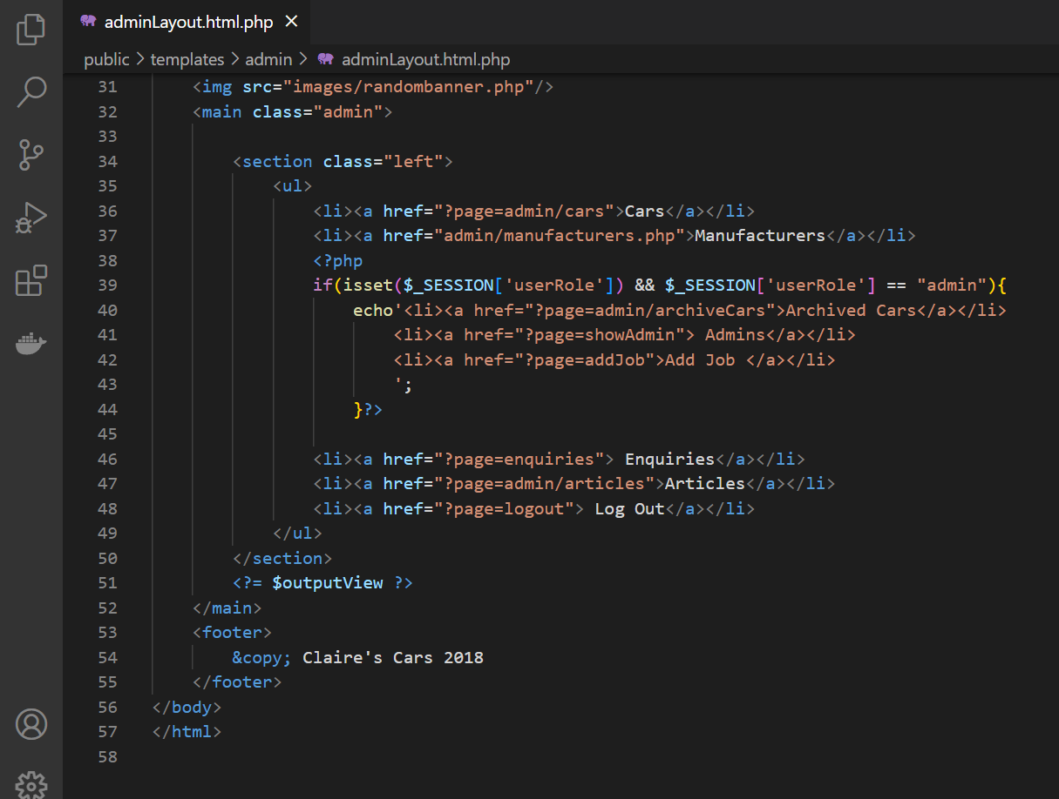

Fig: code for admin layout

**Autoloader**

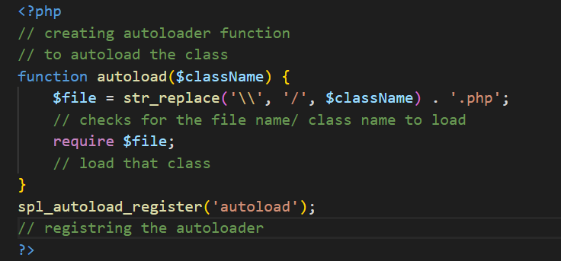

Fig: function to autoload classes

**Implemented Features**

**1 :) Change to Sunday closed:**

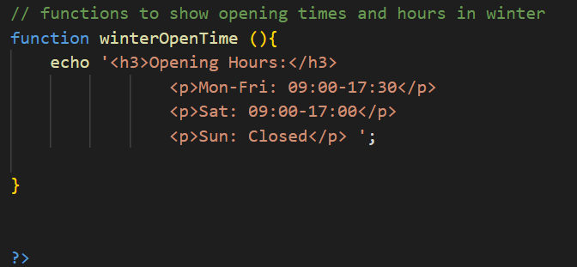

Sunday closed function is written in templateLoader class.

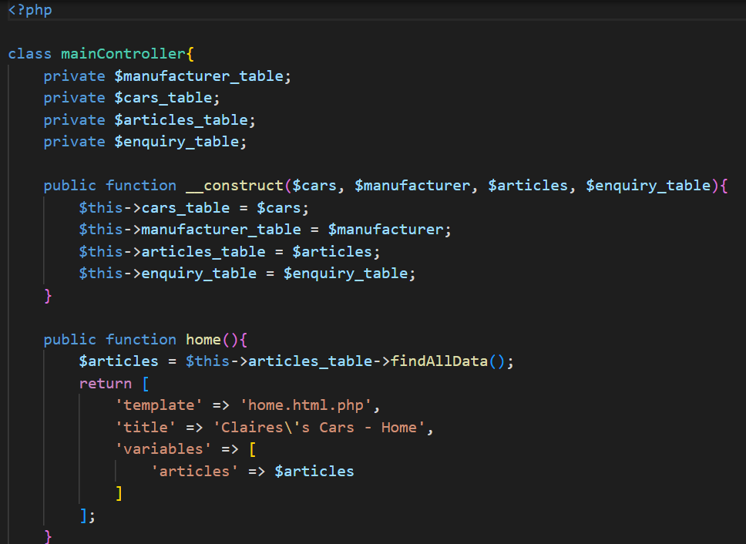

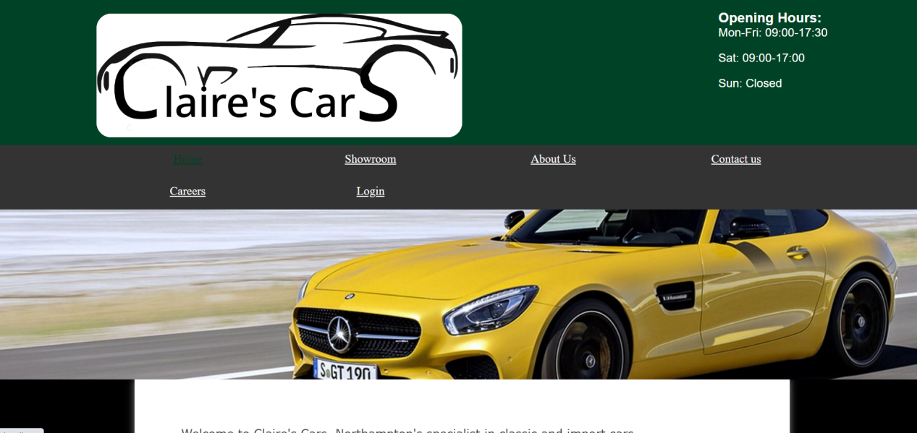

The website now shows the Sunday closed.

**2 :) New Page called ‘Claire’s Careers’:**

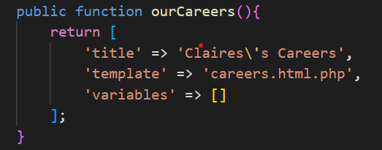

This function of main controller is needed to load careers page

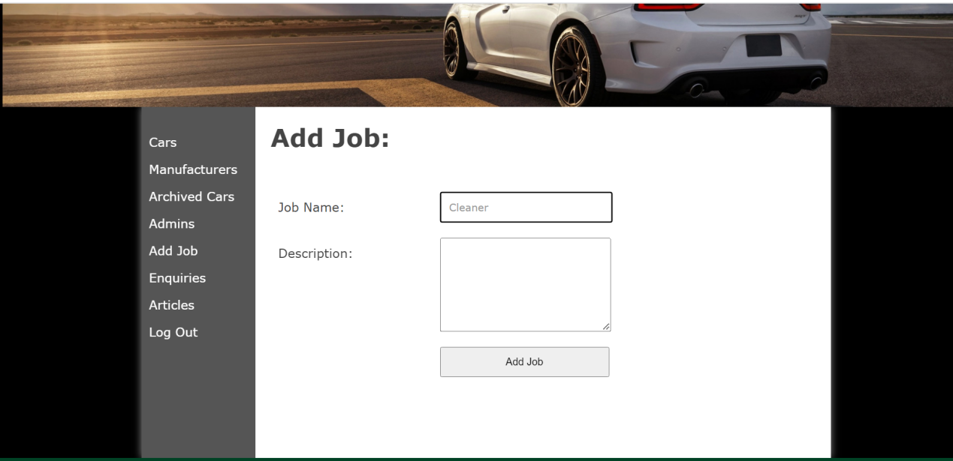

Admin Can now add Job and Description which is stored in database.

**3: ) The added manufacturers appears on the list on the Showroom page:**

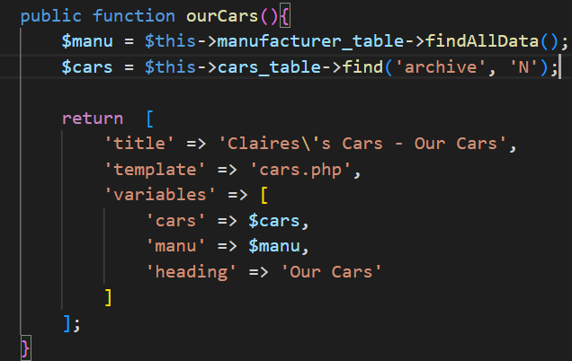

This is the controller for the showroom page. It fetches all the data from manufacturer table and cars that are not archived and pass to cars.php.

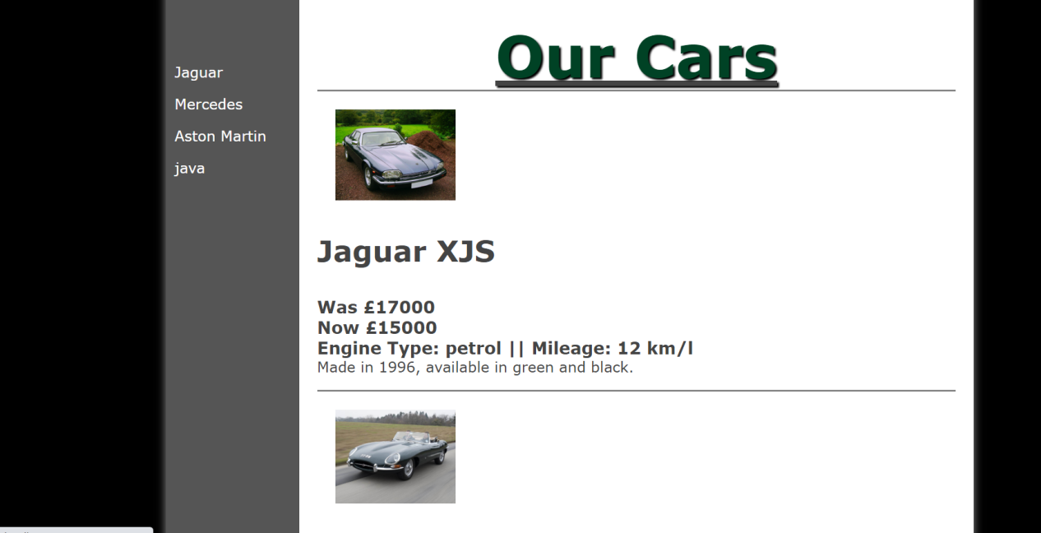

Fig: Sidebar listing all the manufacturers in showroom page

**4: ) Archive and Restore car:**

To implement this feature I have used same html page for admin cars page and the archived cars page.

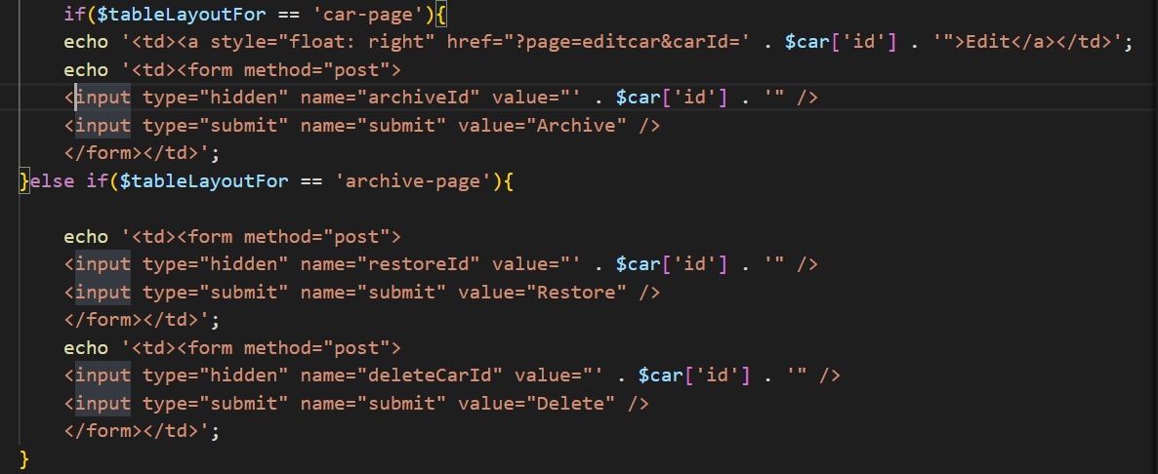

Fig: Section of templates/admin/cars.html.php

The controller passes the $tableLayoutFor value, if user request for the cars page the value of this variable is set to car-page and the Edit and Archive button is shown in cars page. If the requested page is archive-page the two button Restore and delete will be visible.

The controller shown below is to archive car, archive-page, restore car, If user pressed the archive button the attribute ‘archive’ of that car will be set to ‘Y’, If user pressed for restore, ‘archive’ will set to ‘N’.

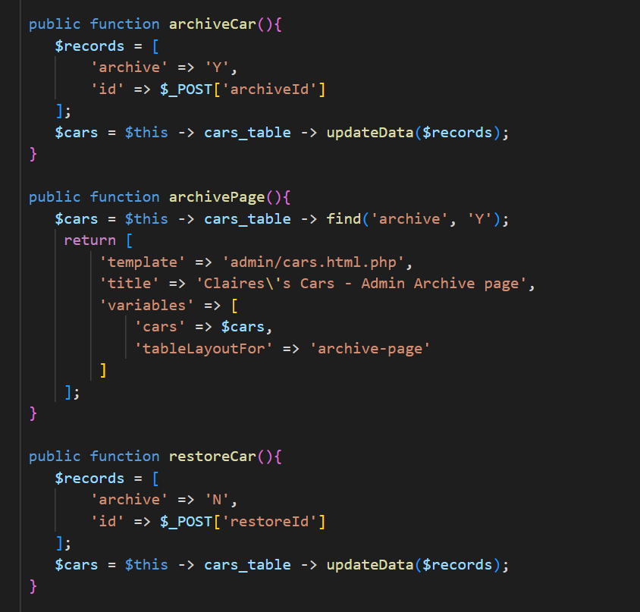

Fig: Controller for the archive, restore feature

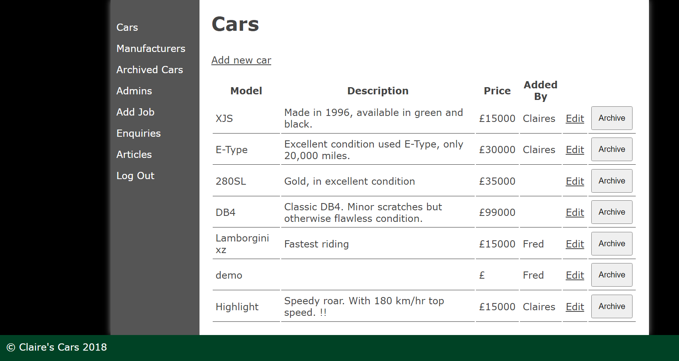

Fig: Showing archive and Edit for each car in cars page

Here, the car (Highlight) is now archived which will now shown in archived car page.

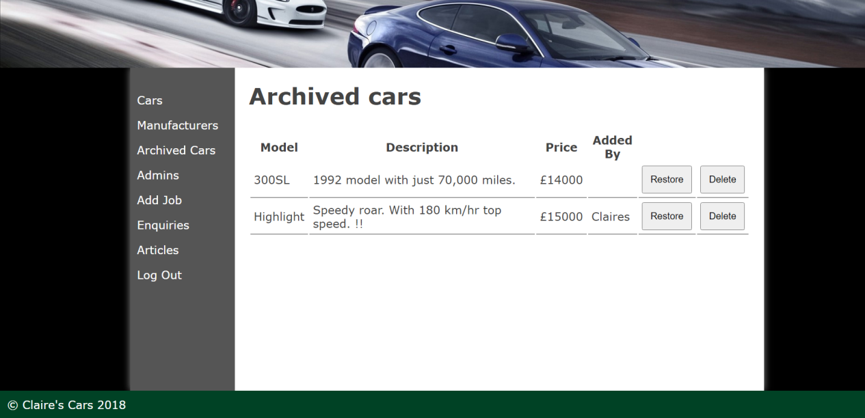

Fig: Showing archived cars.

**5 :) Able to store the earlier price:**

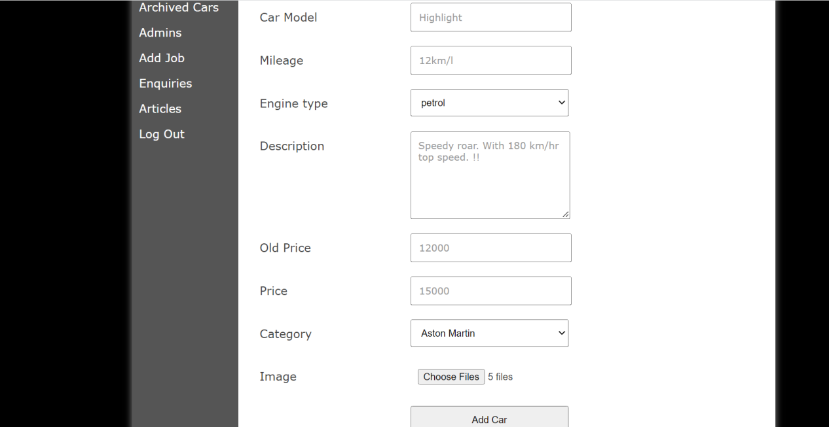

Fig: Adding new car by admin

Now , Old price can also be added which will be shown to the website.

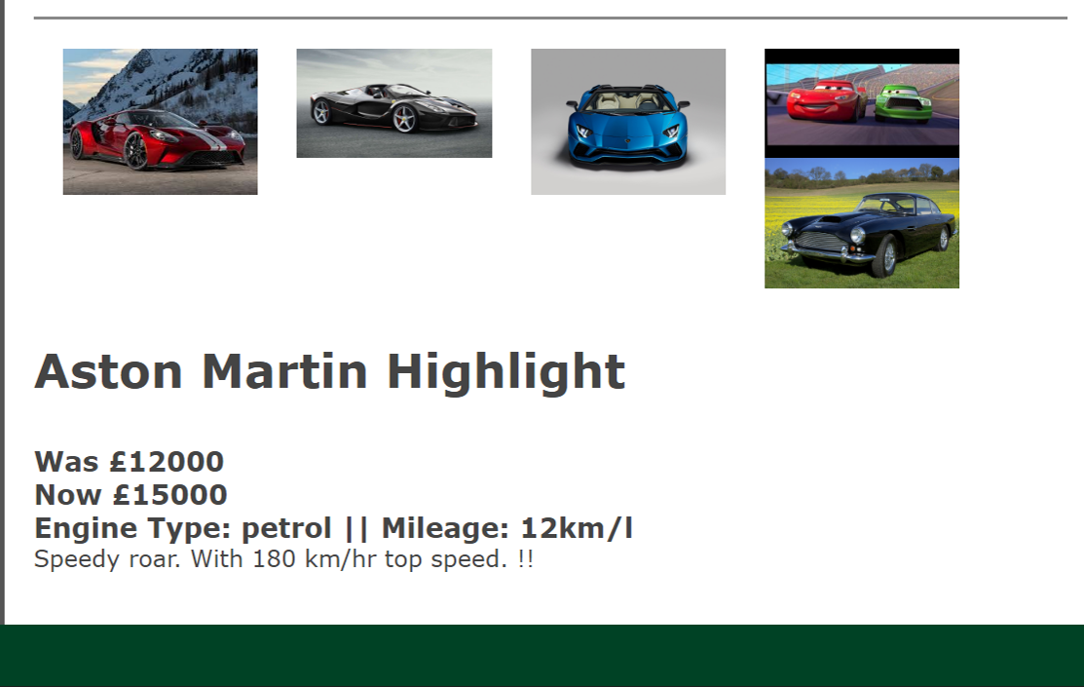

Fig: Showing old price of the car

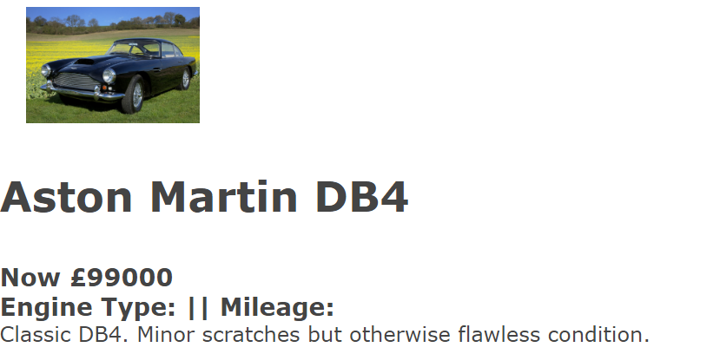

Fig: Showing current price only

The car not having old price shows only current price in the showroom page.

**6:) Able to add Multiple user and separate login using username, and password:**

The controller for the add Admin page is given. If admin submit new user details it will pass to database to insert data in database.

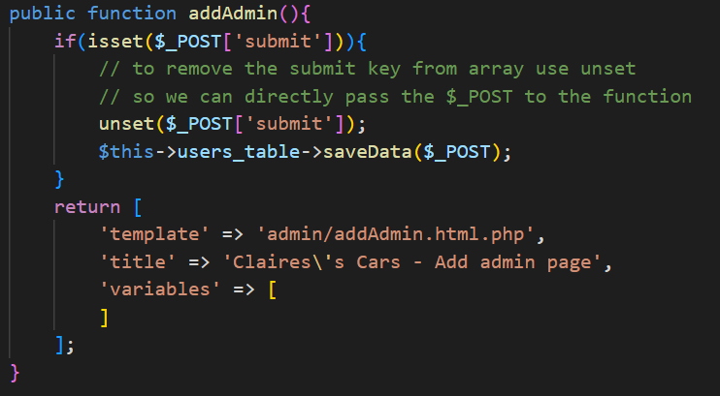

Fig: controller code for the addAdmin

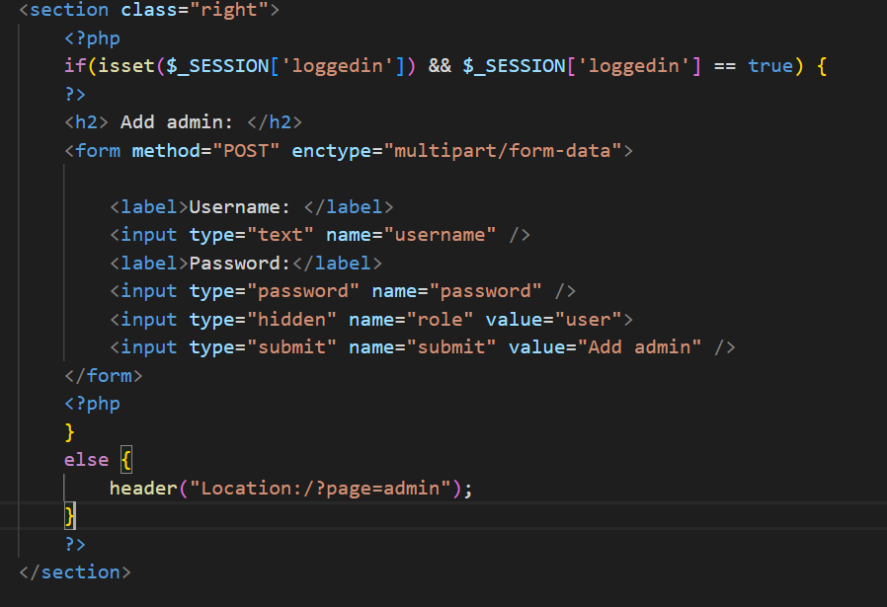

Fig: Form HTML for adding new users

Admin User can add multiple user through use of username and password. Here two users Jacky and Rider is added by admin which can be verify in admins section of the website.

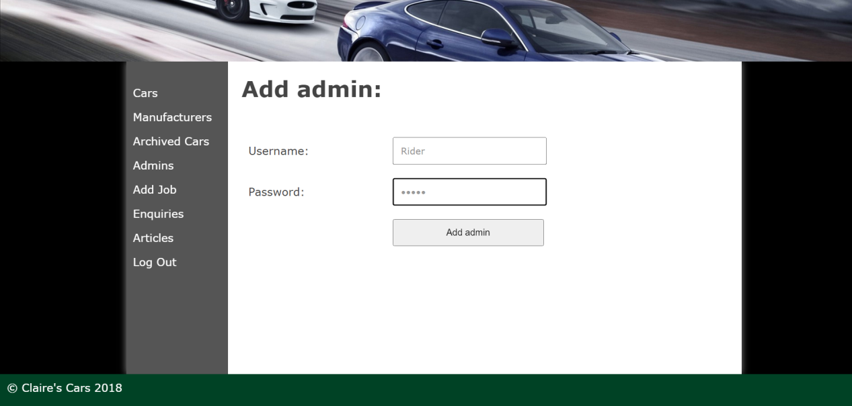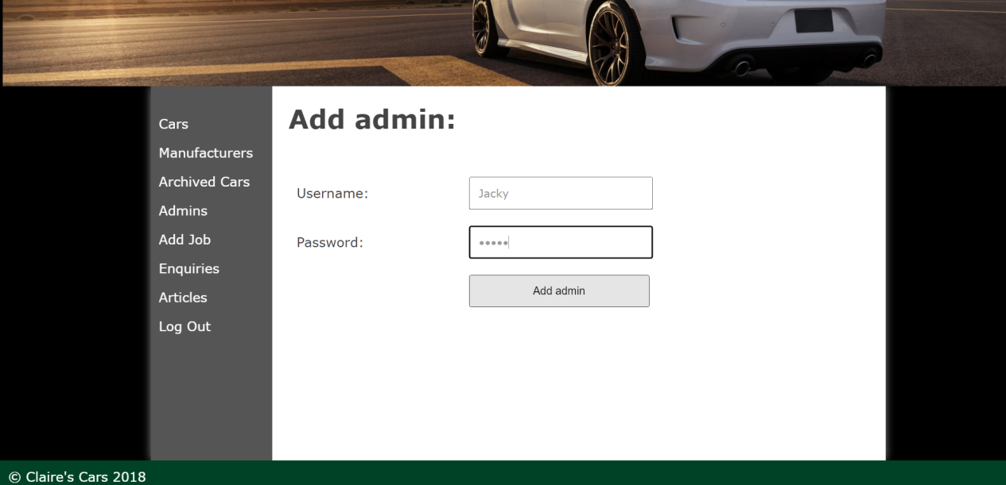

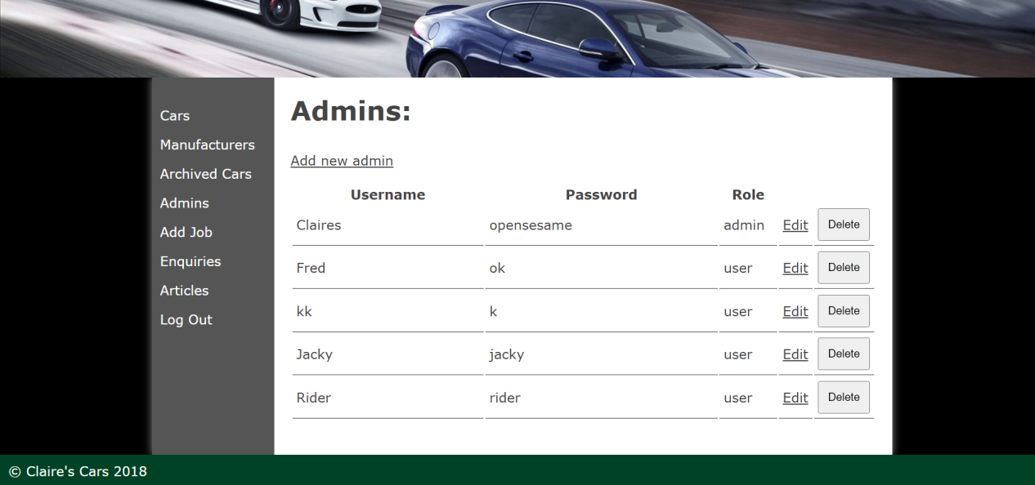

Fig: Admin section viewed by the admin

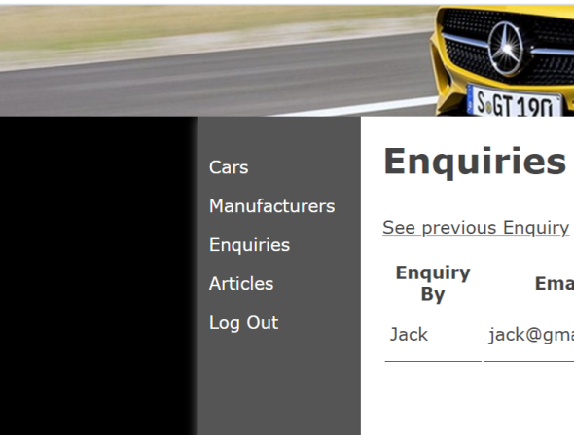

Fig: When users other than ADMIN logged in the website

The following features shown in sidebar is only accessible to USER (like FRED) other than ADMIN.

**7:) Separate field for storing mileage, engine type(petrol or diesel):**

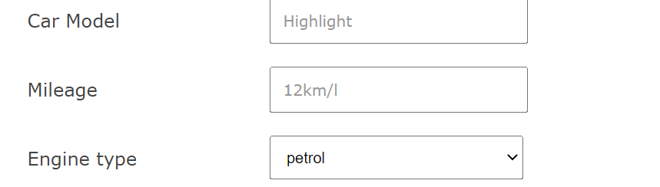

Fig: form to add car

Now, user can add mileage, engine type of the car.



The added engine type and Mileage can be viewed by the public

**8: ) Adding multiple images:**

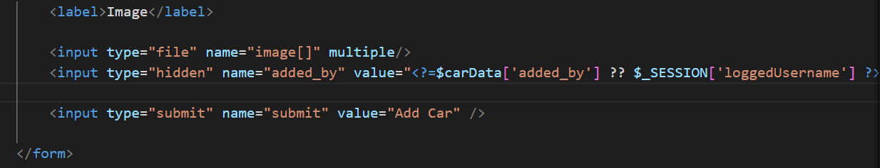

Fig: changes in form

To add multiple images, image array is used with multiple attribute which helps to upload multiple images.

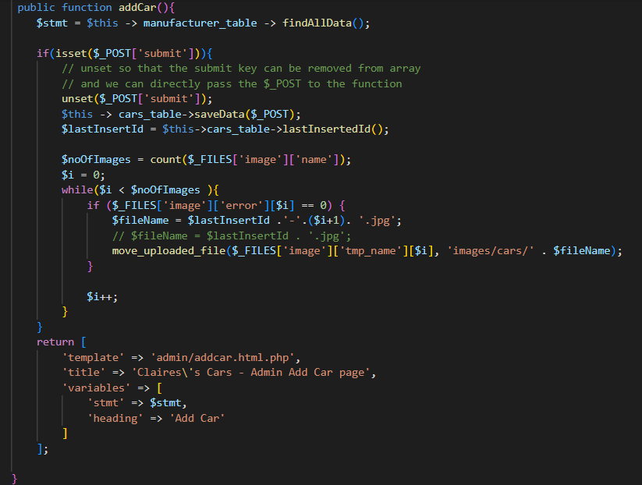

Fig: addCar() function in controller

The controller adds the data inserted in the add car form. First it insert the values in the table and fetch that new inserted id by use of lastInsertedId() function which is defined in dbTable.php then, counts all the images in the array and add to the following directory by use of while loop and the image name will be joined with ‘-’ and counter-variable value following by jpg.

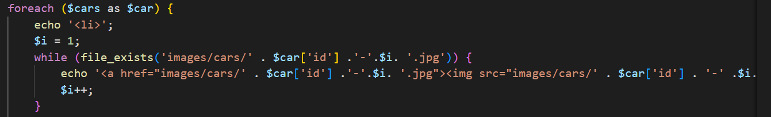

Fig: displaying multiple images

This code will display multiple images of that car id in the showroom page.



Fig: adding multiple images



Fig: Showing that multiple images in the website

**9: Able to add news stories:**

Articles/ stories can only be added by the logged in user.

The form to add stories is designed as given below:

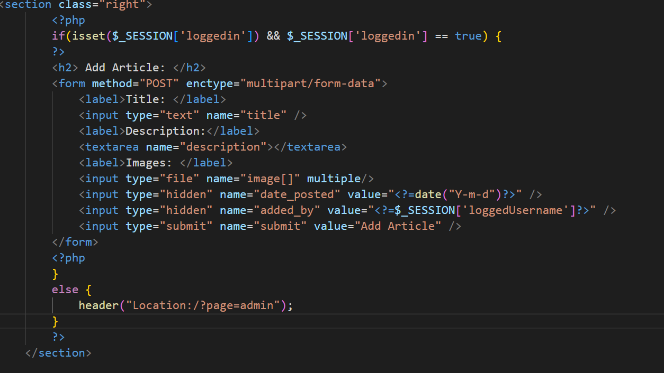

Fig: required HTML for add article form

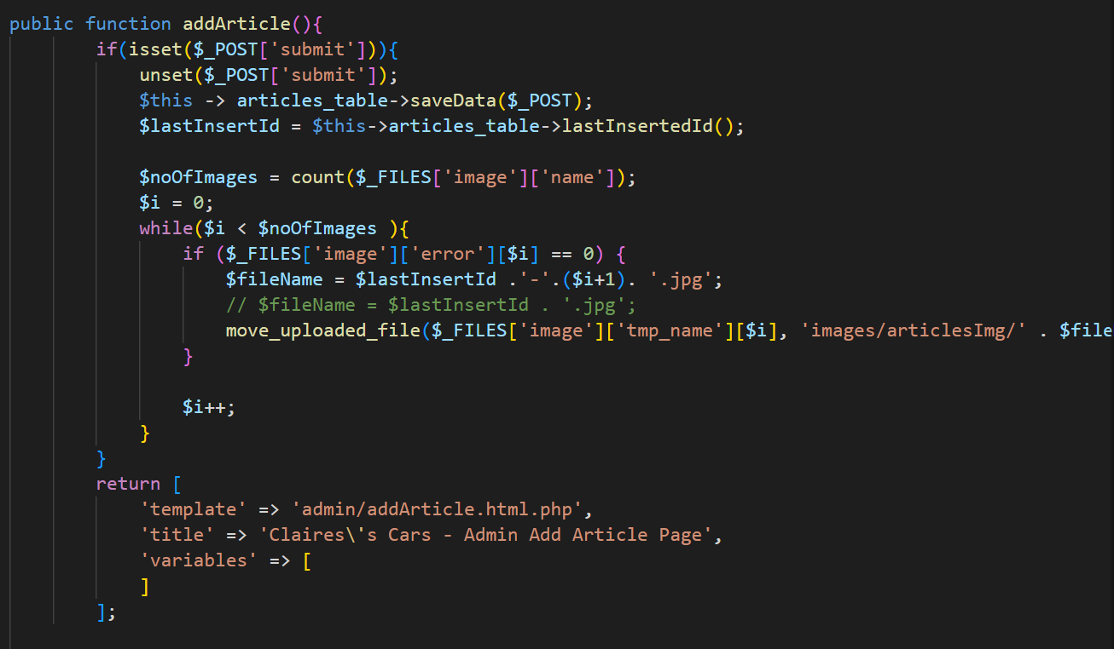

Fig: code for add-Article in controller

When user submits the article it gets stored in the articles table and the image uploaded will be saved in articlesImg inside image folder on the basis of id.

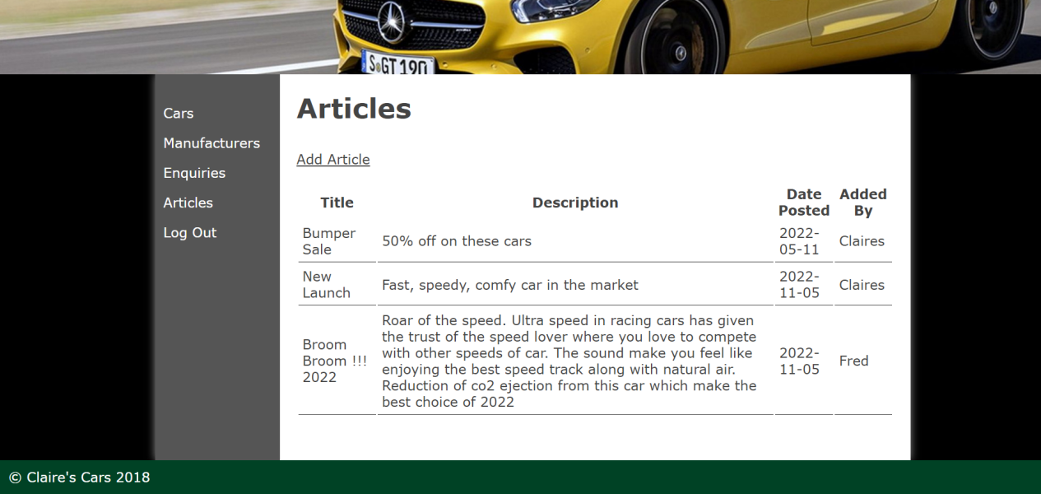

Fig: showing articles listed in admin view

The article added by whom can also be visible by the logged in user

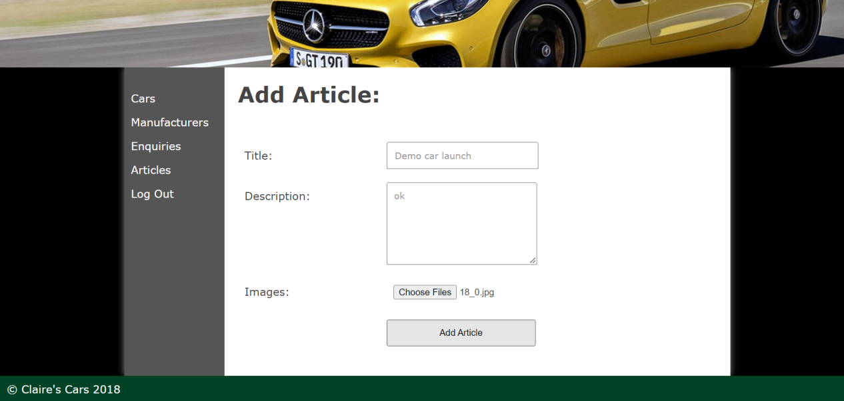

Fig: Adding Article ‘Demo car launch’ with images

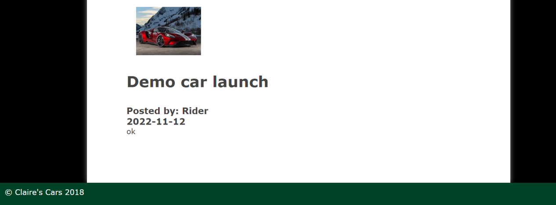

Fig: Displaying added stories in home page

The stories or the articles are visible on the home page.

The posted date of article and the user who posted the article along with title and description is also visible in the website.

**10 :) Enquiry form in the contact page.**

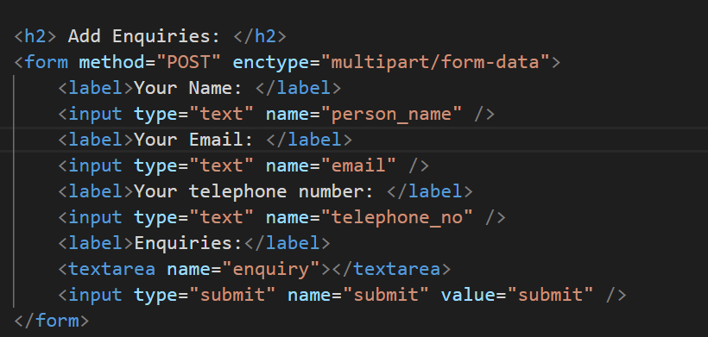

Fig: Enquiry form

The form can be visible on the contact page of the website. The form is designed as shown in fig.

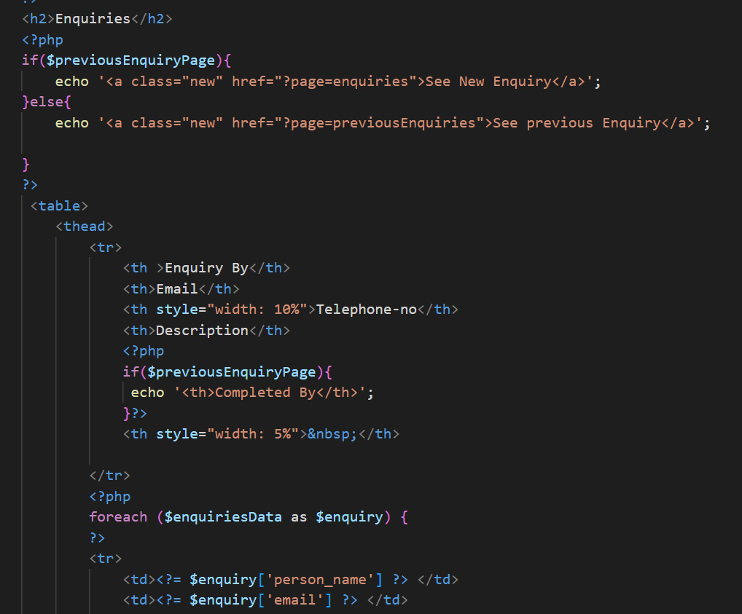

Fig: Enquiry section of the admin view

All enquiry are displayed to the admins enquiry section in the tabular structure which is designed as fig

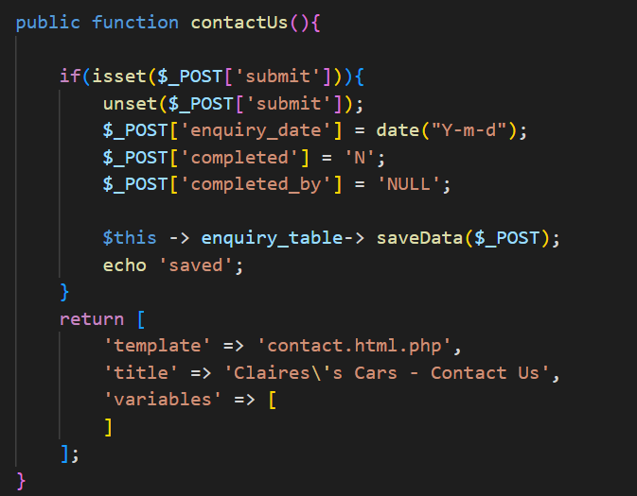

Fig: contactUs() function in controller

If user submits the enquiry the data gets stored in the enquiry table and the following enquiry can be viewed by the admin.

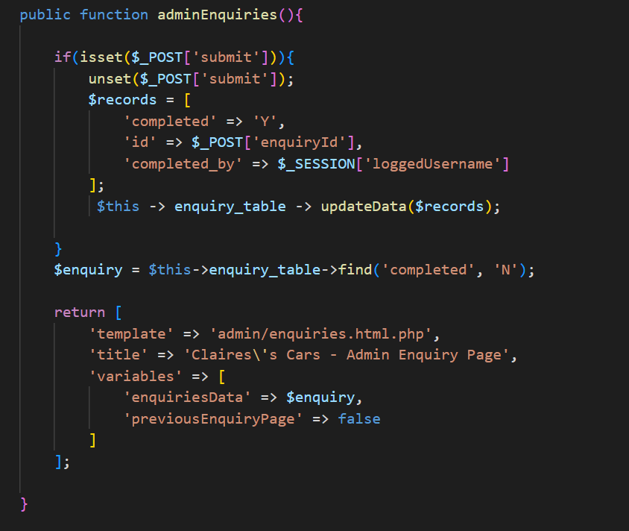

Fig: function to display all enquiries in admin section

All public posted enquiries are visible in enquiry section of the admin and admin can complete the enquiry. If users marks complete to the enquiry the field ‘completed’ of that enquiry will be set as ‘Y’.

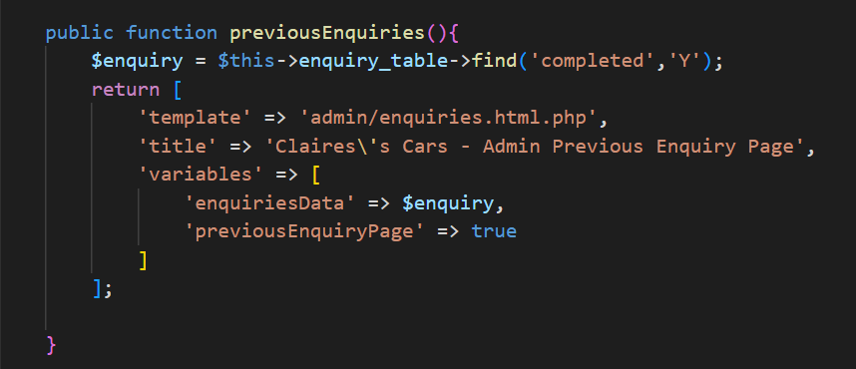

Fig: adminController function showing previous inquiries

The previous enquiries are filtered by the ‘Y’ character in the ‘completed’ field of that record.

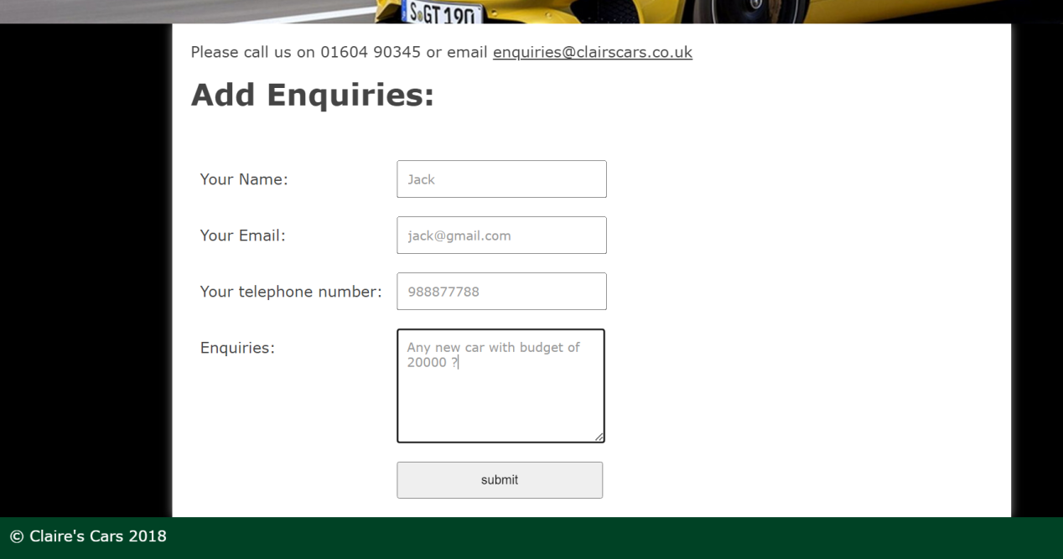

Fig: adding enquiries from contact page

Here, adding the enquiry by the public user with following details

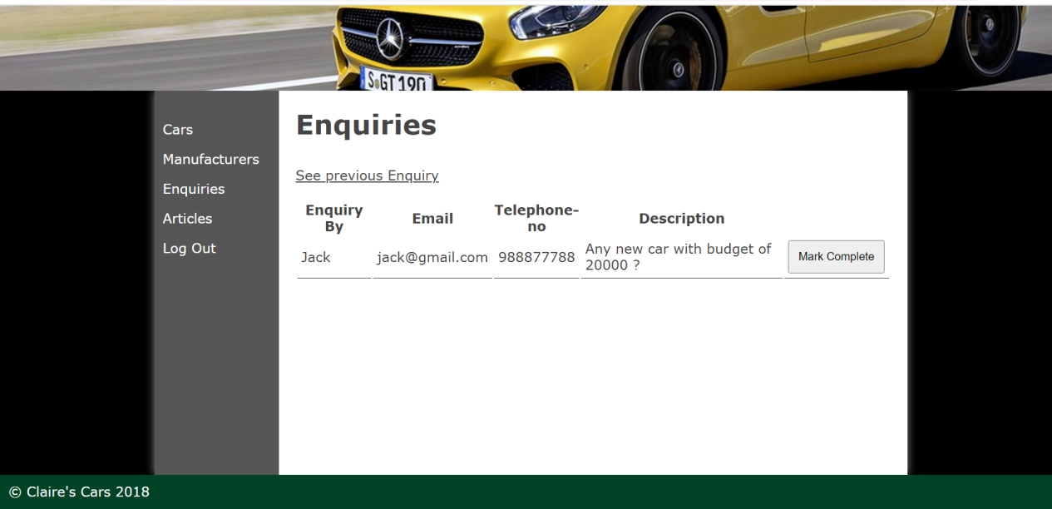

Fig: Enquiry section of the admin

All incomplete inquiries are shown in this section of the admin. After completion of the enquiry if the users marks as complete the following enquiry will be completed and not visible in this section.

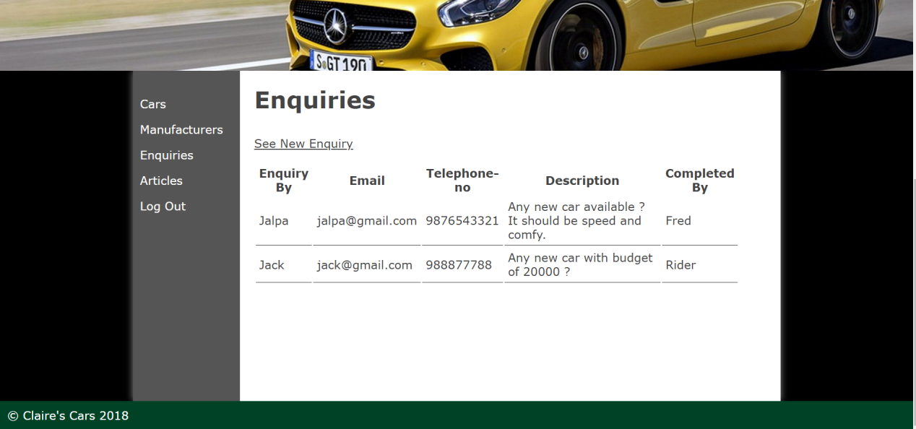

Fig: showing previous enquiries

All completed inquiries are visible after clicking see previous enquiry button. The enquiry details and the user who completed enquiry are also visible in this page.

### Evidence of Testing:

|  |  |  |  |
| --- | --- | --- | --- |
| Test | Expected Result | Result as expected | Screenshot |
| Homepage | Should displays stories added by admin with multiple images. | Yes | 1 |
| Showroom page | Should list all cars that are not added to archived | Yes | 2 |
| Manufacturers in showroom page | List all manufacturers name in sidebar. And displays the cars of that manufacturer when its name is clicked | Yes | 3 |
| Adding enquiry via form on contact page | Input value from form is stored in enquiry table | Yes | 4 |
| Career page | Showing message provided by client | Yes | 5 |
|  | | |  |
| Admin Login | Admin should be able to login by entering username and password | Yes |  |
| Other user Login | User having role ‘USER’ in table should be able to login | Yes |  |
| Incorrect details while login | User is not able to logged in to admin panel | Yes |  |
| Add car | Logged User should able to add cars details including mileage, engine-type | Yes | 6 |
| View car | The added cars should be visible in cars section of admin and showroom page | Yes | 7 |
| See User who added the car | Admin can view the user name who added the car. | Yes | 8 |
| Archive car | Should archive the car when and archive button is pressed by the admin, archived cars is only visible via Archived cars page. | Yes | 9 |
| Restore car | The archived can be restore and the car is again visible to website. | Yes | 10 |
| Add multiple images of the car | Admin can add multiple images of the car, added images should be visible in the website | Yes | 11 |
| Add multiple user | Admin can add multiple user with different username, password. Added user can logged in to the website. | Yes | 12 |
| Add Article/ Stories | Logged user can add stories with multiple images. Added articles are visible in the homepage of the website. | Yes | 13 |
| View Enquiries | Admin can view all the enquiries made by public. | Yes | 14 |
| Mark complete to enquiry | When enquiry is completed user can mark that enquiry as completed and that completed enquiry is not visible in that page any more | Yes | 15 |
| See previous enquiry | All previous/completed enquiry are visible to admin and the admin/ user who completed that enquiry is also shown in that page. | Yes | 16 |

**Screenshots of the test:**

|  |  |
| --- | --- |
| Screenshot No |  |
| 1 | Screenshot (495) |
| 2,3 | Screenshot (496) |
| 4 | Screenshot (497) |
| 5 |  |
| 6 | Screenshot (500) |
| 7,8 | Screenshot (501)  Screenshot (502) |
| 9,10 | Screenshot (503) |
| 11 | Screenshot (500)  Screenshot (502) |
| 12 | Screenshot (505) |
| 13 | Screenshot (513)Screenshot (514) |
| 14,15 | Screenshot (508) |
| 16 | Screenshot (509) |